Feature selection results for small_dataset and Nmin = 10

Data1 = označava single peak emisije
1. result: (rise_time, pp3, peak_frequency)
Estimated Epsilon: 0.060683, Picked Epsilon: 0.078183, MinNumPoints: 10
DBCV index value: 0.82893
cluster -1 had 0.84746% single peaks
cluster 1 had 97.4576% single peaks
cluster 2 had 1.6949% single peaks
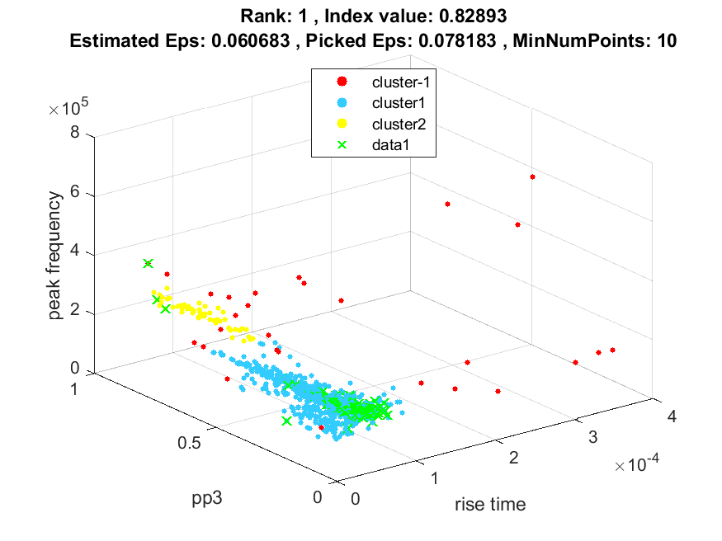
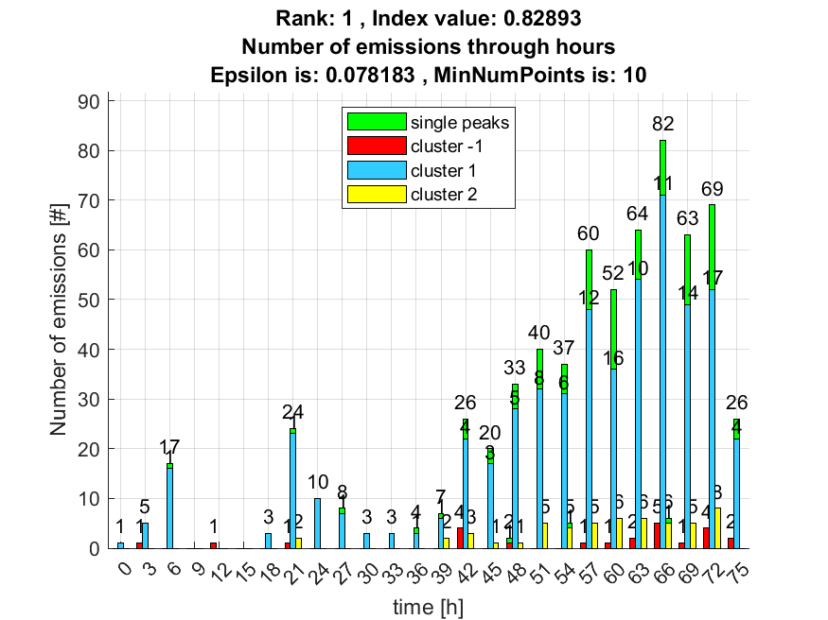

2. result: (signal_strength, peak_frequency, amp_of_peak_frequency)
Estimated Epsilon: 0.028967, Picked Epsilon: 0.038967, MinNumPoints: 10
DBCV index value: 0.82434
cluster -1 had 7.6271% single peaks
cluster 1 had 91.5254% single peaks
cluster 2 had 0.84746% single peaks
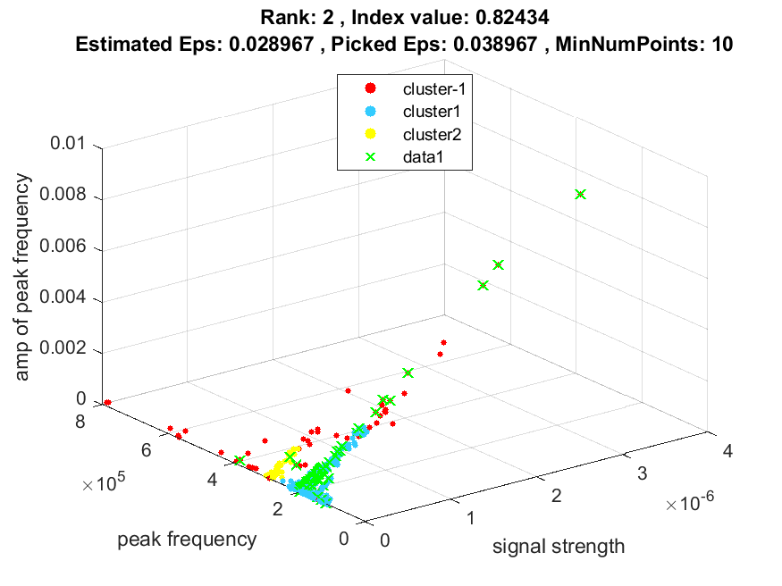
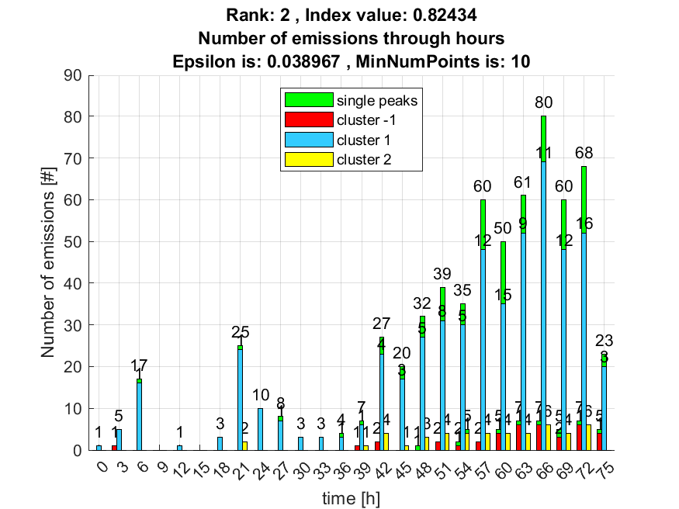

3. result: (pp3, peak_frequency, fall_time)
Estimated Epsilon: 0.053576, Picked Epsilon: 0.063576, MinNumPoints: 10
DBCV index value: 0.81508
cluster -1 had 0.84746% single peaks
cluster 1 had 97.4576% single peaks
cluster 2 had 1.6949% single peaks
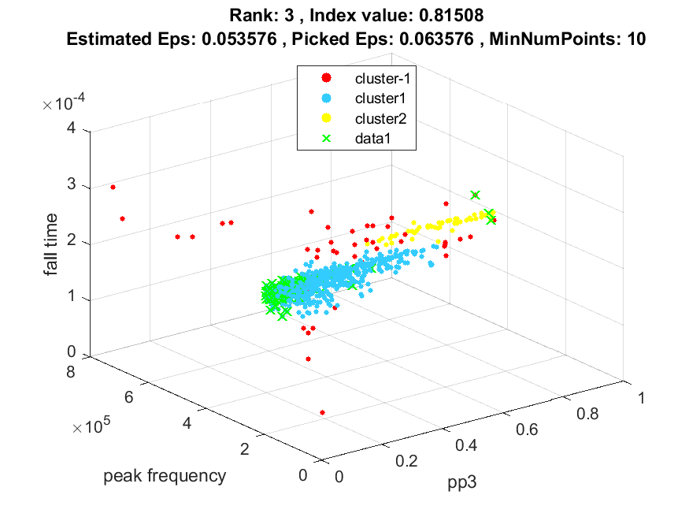
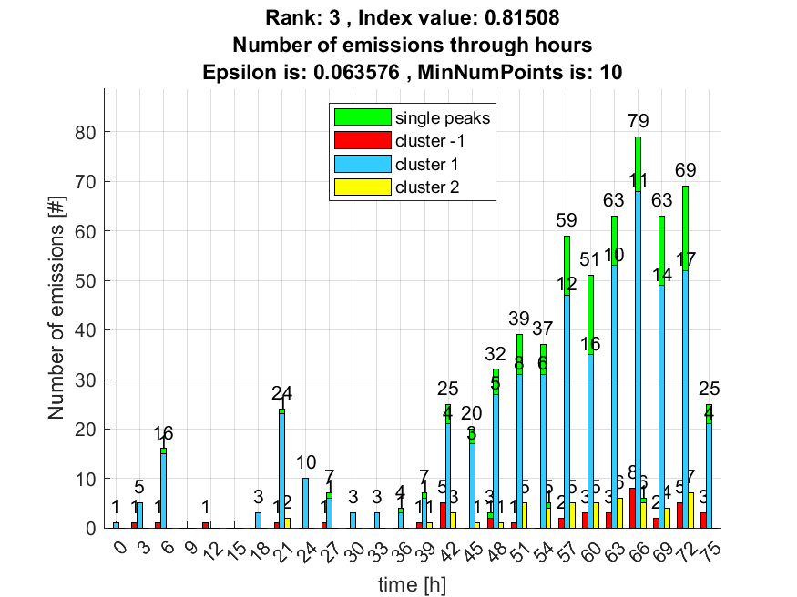

4. result: (rise_time, pp2, peak_frequency)
Estimated Epsilon: 0.062609, Picked Epsilon: 0.075109, MinNumPoints: 10
DBCV index value: 0.81384
cluster -1 had 0.84746% single peaks
cluster 1 had 97.4576% single peaks
cluster 2 had 1.6949% single peaks
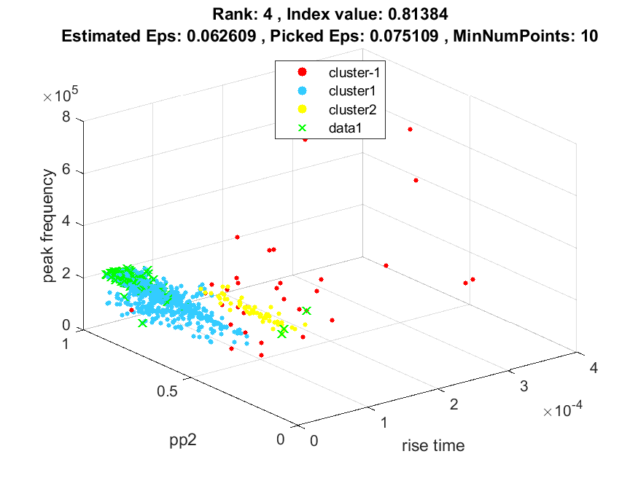
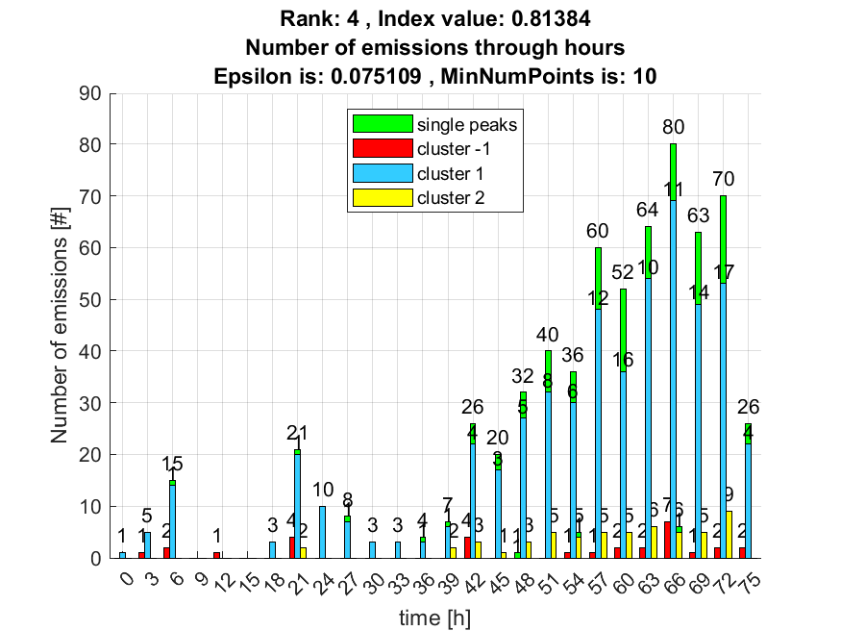

5. result: (pp2, peak_frequency, fall_time)
Estimated Epsilon: 0.057304, Picked Epsilon: 0.069804, MinNumPoints: 10
DBCV index value: 0.80107
cluster -1 had 0.84746% single peaks
cluster 1 had 97.4576% single peaks
cluster 2 had 1.6949% single peaks
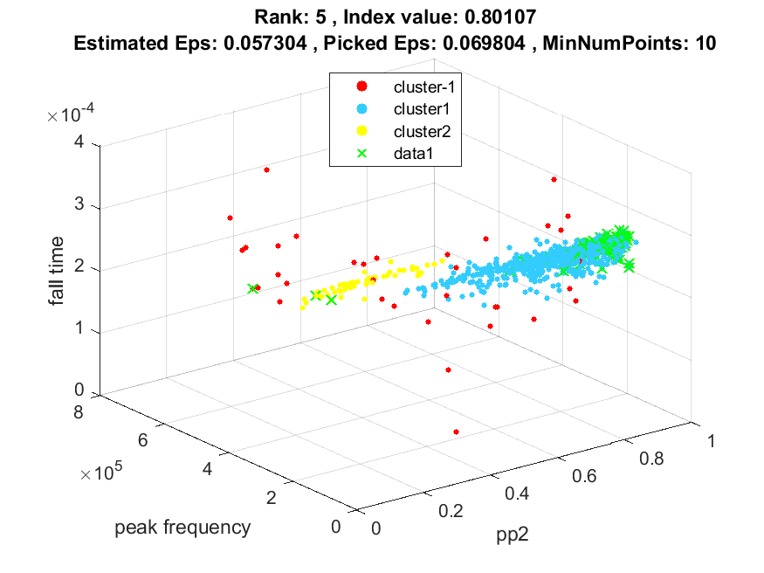
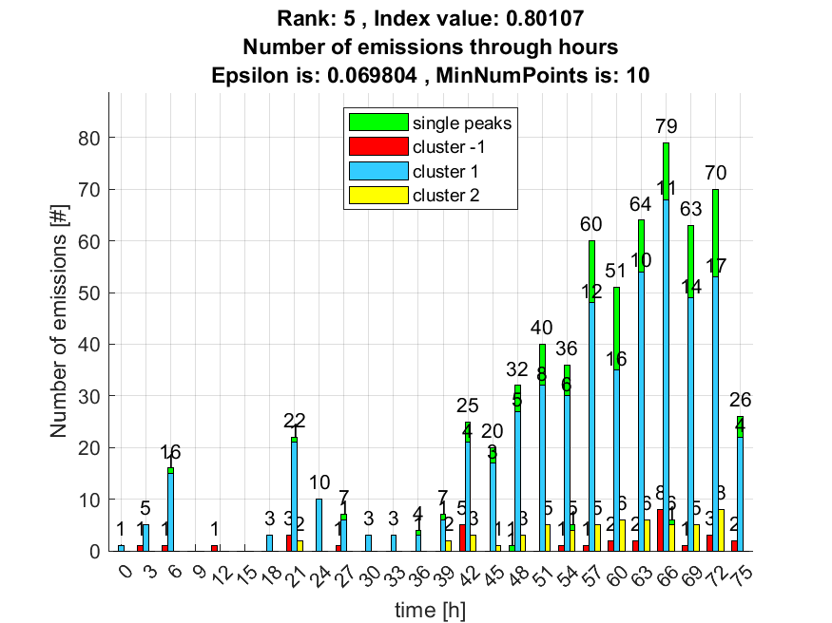

6. result: (signal_strength, pp3, peak_frequency)
Estimated Epsilon: 0.069955, Picked Epsilon: 0.077455, MinNumPoints: 10
DBCV index value: 0.80043
cluster -1 had 6.7797% single peaks
cluster 1 had 91.5254% single peaks
cluster 2 had 1.6949% single peaks
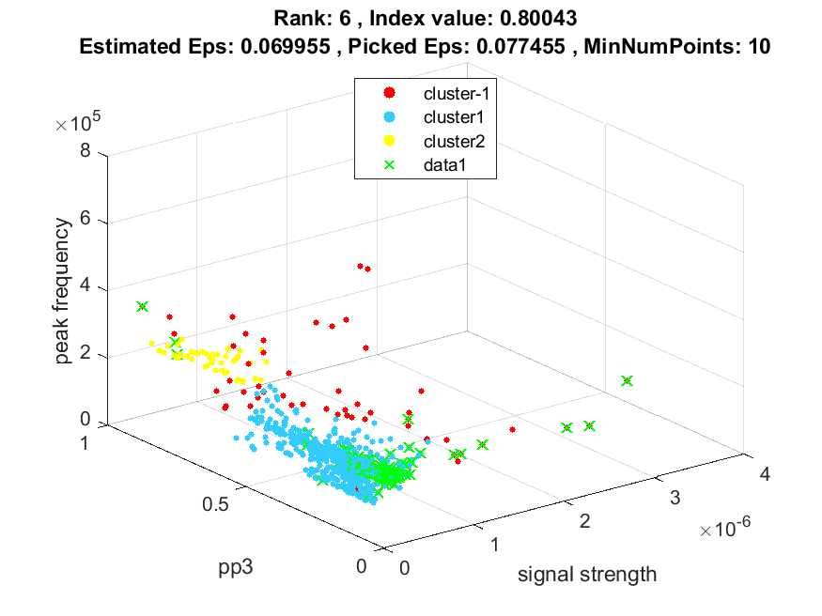
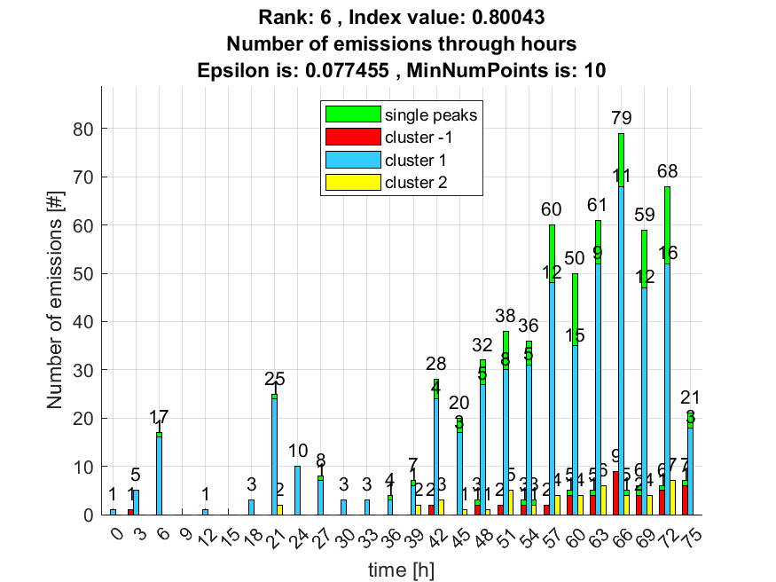

7. result: (peak_amplitude, pp3, peak_frequency)
Estimated Epsilon: 0.069149, Picked Epsilon: 0.071649, MinNumPoints: 10
DBCV index value: 0.79969
cluster -1 had 5.0847% single peaks
cluster 1 had 93.2203% single peaks
cluster 2 had 1.6949% single peaks
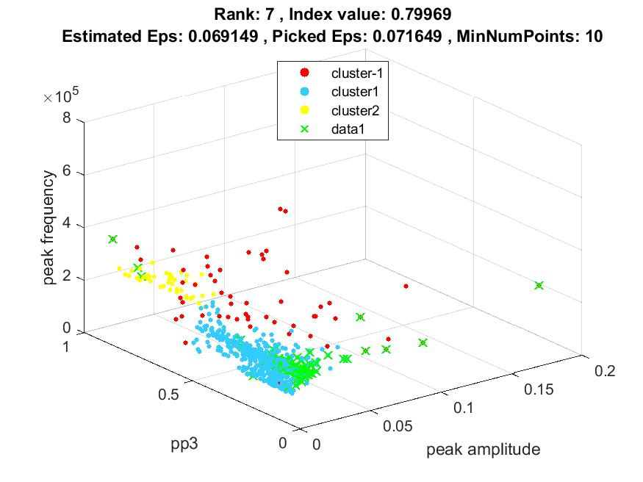
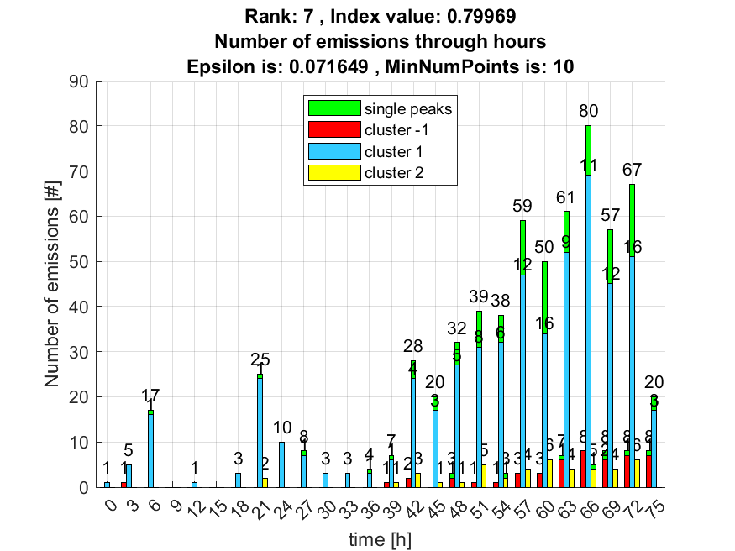

8. result: (pp2, pp3, peak_frequency)
Estimated Epsilon: 0.072057, Picked Epsilon: 0.084557, MinNumPoints: 10
DBCV index value: 0.79796
cluster -1 had 0.84746% single peaks
cluster 1 had 97.4576% single peaks
cluster 2 had 1.6949% single peaks
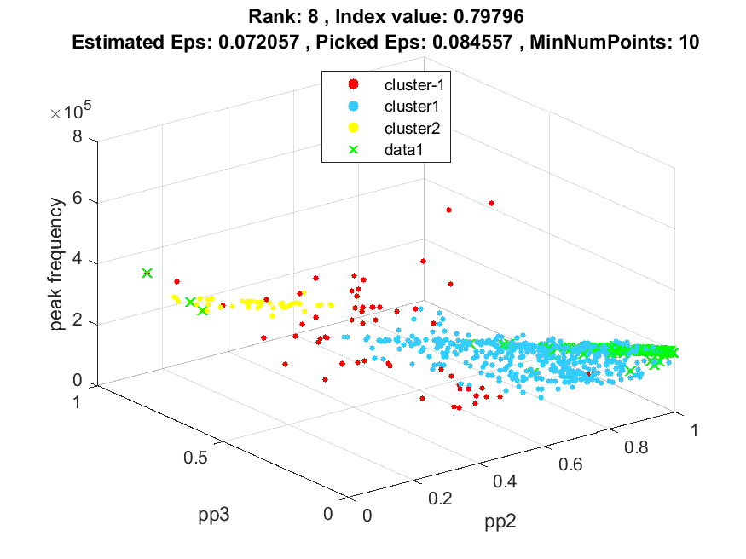
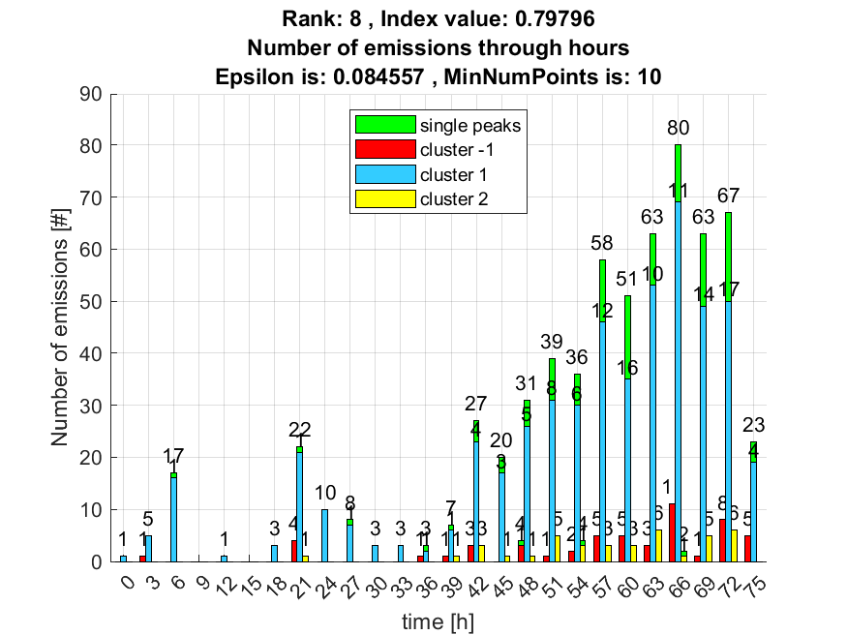

9. result: (peak_amplitude, peak_frequency, amp_of_peak_frequency)
Estimated Epsilon: 0.04127, Picked Epsilon: 0.03877, MinNumPoints: 10
DBCV index value: 0.79701
cluster -1 had 9.322% single peaks
cluster 1 had 89.8305% single peaks
cluster 2 had 0.84746% single peaks
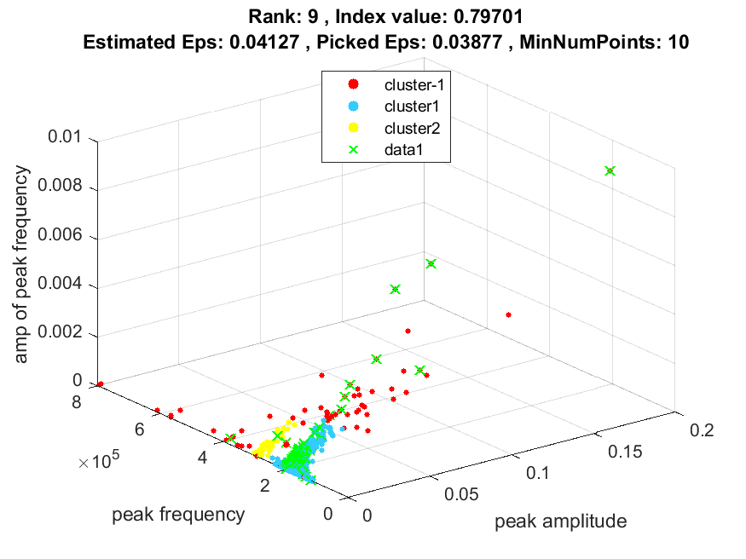
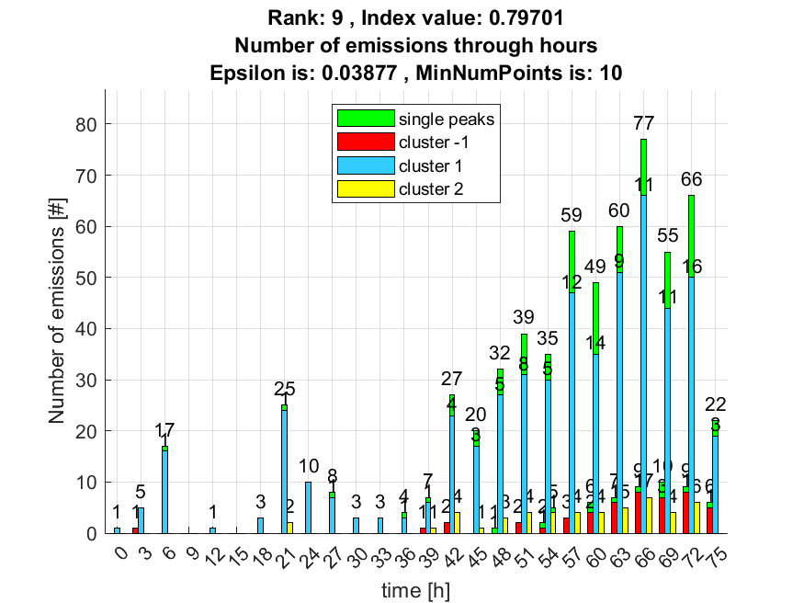

10. result: (signal_strength, pp2, peak_frequency)
Estimated Epsilon: 0.060104, Picked Epsilon: 0.077604, MinNumPoints: 10
DBCV index value: 0.79369
cluster -1 had 6.7797% single peaks
cluster 1 had 91.5254% single peaks
cluster 2 had 1.6949% single peaks
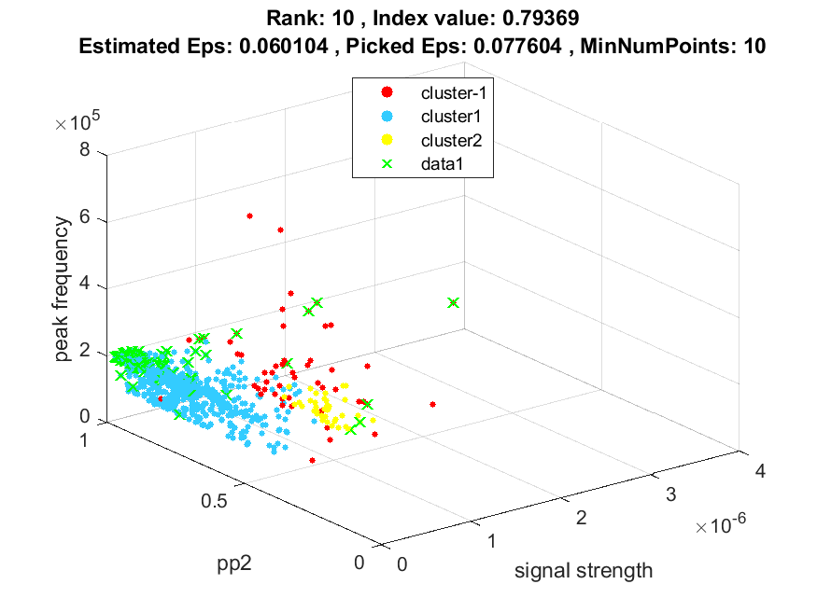
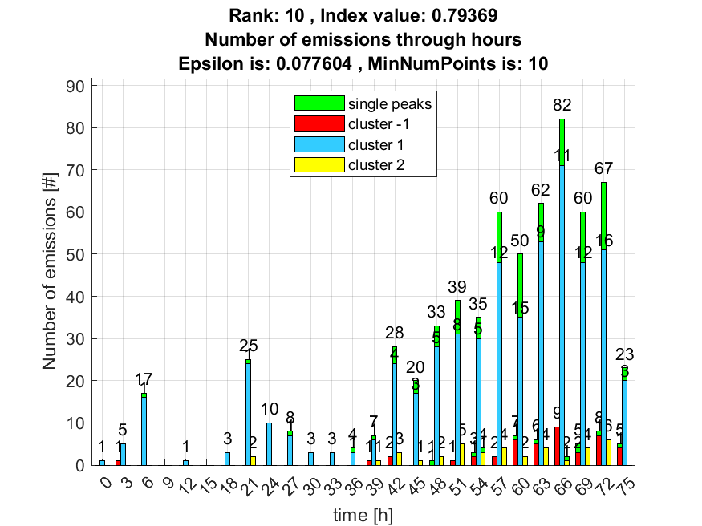

Kao dodatna informacija priložio sam sličnosti navedenih 10 rezultata kao postotak sličnosti svih clustera između svih parova rezultata. Gdje je svaki red i svaki stupac predstavlja određeni cluster navedenog rangiranog rezultata. Clusteri idu po redu kako su označeni na slici uključujući outliere kao cluster označen s -1.
Intersection between rank 1 and rank 2 :
0.7179 0 0
0.0136 0.9864 0
0.0364 0 0.9636

Intersection between rank 1 and rank 3 :
0.7179 0 0
0.0136 0.9864 0
0.0364 0 0.9636

Intersection between rank 1 and rank 4 :
0.8235 0 0
0.0091 0.9879 0.0030
0 0 0.9649

Intersection between rank 1 and rank 5 :
0.8235 0 0
0.0091 0.9879 0.0030
0 0 0.9649

Intersection between rank 1 and rank 6 :
0.7179 0 0
0.0136 0.9864 0
0.0364 0 0.9636

Intersection between rank 1 and rank 7 :
0.6087 0 0
0.0211 0.9789 0
0.0727 0 0.9273

Intersection between rank 1 and rank 8 :
0.8235 0 0
0.0091 0.9879 0.0030
0 0 0.9649

Intersection between rank 1 and rank 9 :
0.4000 0 0
0.0302 0.9698 0
0.3143 0 0.6000

Intersection between rank 1 and rank 10 :
1 0 0
0 1 0
0 0 1

Intersection between rank 2 and rank 3 :
1 0 0
0 1 0
0 0 1

Intersection between rank 2 and rank 4 :
0.8718 0.0015 0.0702
0 0.9985 0
0 0 0.9298

Intersection between rank 2 and rank 5 :
0.8718 0.0015 0.0702
0 0.9985 0
0 0 0.9298

Intersection between rank 2 and rank 6 :
1 0 0
0 1 0
0 0 1

Intersection between rank 2 and rank 7 :
0.8478 0 0
0.0077 0.9923 0
0.0377 0 0.9623

Intersection between rank 2 and rank 8 :
0.8718 0.0015 0.0702
0 0.9985 0
0 0 0.9298

Intersection between rank 2 and rank 9 :
0.5571 0 0
0.0168 0.9832 0
0.2857 0 0.6226

Intersection between rank 2 and rank 10 :
0.7179 0.0136 0.0364
0 0.9864 0
0 0 0.9636

Intersection between rank 3 and rank 4 :
0.8718 0.0015 0.0702
0 0.9985 0
0 0 0.9298

Intersection between rank 3 and rank 5 :
0.8718 0.0015 0.0702
0 0.9985 0
0 0 0.9298

Intersection between rank 3 and rank 6 :
1 0 0
0 1 0
0 0 1

Intersection between rank 3 and rank 7 :
0.8478 0 0
0.0077 0.9923 0
0.0377 0 0.9623

Intersection between rank 3 and rank 8 :
0.8718 0.0015 0.0702
0 0.9985 0
0 0 0.9298

Intersection between rank 3 and rank 9 :
0.5571 0 0
0.0168 0.9832 0
0.2857 0 0.6226

Intersection between rank 3 and rank 10 :
0.7179 0.0136 0.0364
0 0.9864 0
0 0 0.9636

Intersection between rank 4 and rank 5 :
1 0 0
0 1 0
0 0 1

Intersection between rank 4 and rank 6 :
0.8718 0 0
0.0015 0.9985 0
0.0702 0 0.9298

Intersection between rank 4 and rank 7 :
0.7391 0 0
0.0092 0.9908 0
0.1053 0 0.8947

Intersection between rank 4 and rank 8 :
1 0 0
0 1 0
0 0 1

Intersection between rank 4 and rank 9 :
0.4857 0 0
0.0183 0.9817 0
0.3429 0 0.5789

Intersection between rank 4 and rank 10 :
0.8235 0.0091 0
0 0.9879 0
0 0.0030 0.9649

Intersection between rank 5 and rank 6 :
0.8718 0 0
0.0015 0.9985 0
0.0702 0 0.9298

Intersection between rank 5 and rank 7 :
0.7391 0 0
0.0092 0.9908 0
0.1053 0 0.8947

Intersection between rank 5 and rank 8 :
1 0 0
0 1 0
0 0 1

Intersection between rank 5 and rank 9 :
0.4857 0 0
0.0183 0.9817 0
0.3429 0 0.5789

Intersection between rank 5 and rank 10 :
0.8235 0.0091 0
0 0.9879 0
0 0.0030 0.9649

Intersection between rank 6 and rank 7 :
0.8478 0 0
0.0077 0.9923 0
0.0377 0 0.9623

Intersection between rank 6 and rank 8 :
0.8718 0.0015 0.0702
0 0.9985 0
0 0 0.9298

Intersection between rank 6 and rank 9 :
0.5571 0 0
0.0168 0.9832 0
0.2857 0 0.6226

Intersection between rank 6 and rank 10 :
0.7179 0.0136 0.0364
0 0.9864 0
0 0 0.9636

Intersection between rank 7 and rank 8 :
0.7391 0.0092 0.1053
0 0.9908 0
0 0 0.8947

Intersection between rank 7 and rank 9 :
0.6571 0 0
0.0093 0.9907 0
0.2571 0 0.6471

Intersection between rank 7 and rank 10 :
0.6087 0.0211 0.0727
0 0.9789 0
0 0 0.9273

Intersection between rank 8 and rank 9 :
0.4857 0 0
0.0183 0.9817 0
0.3429 0 0.5789

Intersection between rank 8 and rank 10 :
0.8235 0.0091 0
0 0.9879 0
0 0.0030 0.9649

Intersection between rank 9 and rank 10 :
0.4000 0.0302 0.3143
0 0.9698 0
0 0 0.6000

